Perspectives of ZnO:Al layers deposited by PLD method as transparent emitter electrodes for flexible solar cells
Maciej Sibiński^{1*}, Katarzyna Znajdek¹, Mirosław Sawczak², Michał Górski²,
¹DEPARTMENT OF OPTOELECTRONICS AND SEMICONDUCTOR DEVICES, LODZ UNIVERSITY OF TECHNOLOGY
211/215 Wólczanska, 90-924
Łódź, Poland
²POLISH ACADEMY OF SCIENCES, INSTITUTE OF FLUID-FLOW MACHINERY
14 Fiszera, 80-952
Gdańsk, Poland
*e-mail address: maciej.sibinski@p.lodz.pl
Keywords
photovoltaics, zinc oxide, transparent conductive oxides, flexible solar cells.
Abstract
The paper presents investigation of aluminum doped zinc oxide (ZnO:Al or AZO) layers in terms of their application as transparent front contacts in flexible photovoltaic cells. Studied ZnO:Al thin films were deposited using pulsed laser deposition technique (PLD). The essential parameters of obtained AZO transparent conductive layers (TCL), such as optical transmission, resistance per square and mechanical durability, were measured and analyzed.

Introduction
Transparent emitter electrodes for flexible solar cell applications determine one of the key challenges in new generation photovoltaic technology. Such layers should meet the compromise between the highest possible optical transmission (at least 80% for visible spectrum) and the lowest sheet resistance [1]. Moreover, the structure must be bending resistant and its electrical parameters should be sufficiently stable under the influence of mechanical stresses [2]. Materials, commonly used for that purpose are ITO, FTO, Zn₂SnO₄, Cd₂SnO₄, AZO [3-5], CdO, ZnO or RuSiO₄ [6]. Also TiO₂ and carbon nanostructure layers are under investigation [7].
Amongst these materials aluminum doped zinc oxide (ZnO:Al or AZO) is one of the most attractive material.It is coused due to its low cost, high abundancy on Earth, low toxicity and low film resistivity [8]. ZnO also benefits from a higher absorption coefficient than other wide bandgap materials as well as easy fabrication methods, which results in lower manufacturing costs of ZnO-based devices. ZnO is typically crystallized in the hexagonal wurtzite structure with possibility of attaining high carrier concentration by the proper material doping [9].
Due to those favorauble properties, authors propose to utilize AZO thin layers obtained by the new, experimental Pulsed Laser Deposition (PLD) method as transparent conductive layer for flexible PV electrode application. This method is one of the laser techniques, widely used in phtovoltaics technology [10-12], unique by high kinetic energy of produced molecules. Using this technique highly stohiometric layers with the resistivity as low as 0.85∙10⁻⁴ Ωcm are possible to be produced [13]. By adjusting of process parameters authors are planning to manufacture flexible, transparent and conductive TCO layer on inexpensive, low-temperature polymer foil.

ZnO:Al film deposition method
The PLD technique uses high power laser pulses to melt, evaporate and ionize material from the surface of a target. The vaporized material, containing neutrons, ions, electrons etc., is known as a laser-produced plasma plume and expands rapidly away from the target surface. Film growth occurs on a substrate upon which some of the plume material recondenses. However, in practice the situation is not so effortless, with a large number of variables affecting the properties of the film, such as laser fluence, background gas pressure and substrate temperature.These variables allow the film properties to be manipulated in order to suit individual applications. Nevertheless, such optimization requires a considerable effort. Indeed, much of the early research into PLD was concentrated on the empirical optimization of deposition conditions for individual materials and applications, without attempting to understand the processes occurring as the material is transported from target to substrate.
The technique of PLD has significant benefits over other film deposition methods, such as:

-) the capability for stoichiometric transfer of material from target to substrate,
-) relatively high deposition rates (this can be achieved at moderate laser fluences, with film thickness controlled in real time by simply turning the laser on and off),
-) high process purity due to the fact that laser is used as an external energy source (thus, deposition can occur in both inert and reactive background gases),
-) the possibility of deposition multilayer films without breaking the vacuum (due to the use of a carousel, housing a number of target materials).
Proposed, experimental PLD system consists of a vacuum chamber equipped with turbo molecular pump and Nd:YAG laser with fourth harmonic generation module and pulse length of 26 ns. The schematic setup of the system is presented in Fig. 1.
Fig. 1: PLD setup: K – vacuum chamber, L – Nd:YAG laser, 1 – inner pressure control system, 2 – oxygen valve, 3 – laser beam track, 4 – focusing lens, 5 – target, 6 – substrate on heated basis [14].
Pulsed laser beam, directed by the mirror system (Fig. 1-3), was focused on the surface of the target (Fig. 1-5) by quartz long focal-length lens (Fig. 1-4). To avoid crater effect on the surface, target was constantly rotated and the evaporated material was subsequently deposited on the substrate. For adhesion improvement substrates were placed on heated base (Fig. 1-6). Inner pressure and gas content were controlled by the system (Fig. 1-1) and a valve (Fig. 1-2) [15]. Material of the target was acquired by pressing of 98% ZnO and 2% Al₂O₃ powders. By this method it was possible to create relatively uniform ZnO:Al layers with thicknesses of 90–100nm. Parameters of the experimental PLD process for each sample type are listed in Table I.

Table I. Parameters of PLD process for ZnO:Al layers
Sample description | Beam wavelength [nm] | Oxygen pressure [mbar]
D1-P3-1 | 355 | 1.2∙10⁻²
D2-P2-1 | 266 | 1.2∙10⁻³
D2-P3-1 | 266 | 1.2∙10⁻²
D2-P3-2 | 266 | 1.2∙10⁻²
D2-P3-3 | 266 | 1.2∙10⁻²

Experimental ZnO:Al layers on flexible substrates
As a result, continous, smooth layer of the ZnO: Al was obtained. Fig. 2 presents examples of deposited ZnO:Al layer on flexible substrates of PET foil (a) and Kapton® foil (b) substrate.
a) 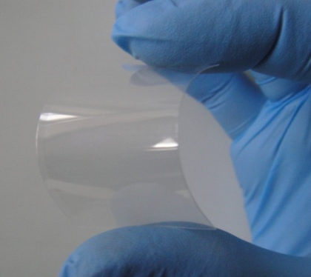 b) 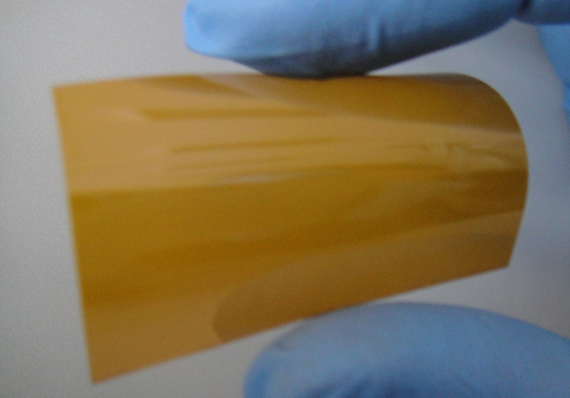
Fig. 2: Thin ZnO:Al layer deposited on PET foil a) and Kapton® b).
The quality of each sample was tested by HRSEM microscopy, which is shown in Fig 3. Strongest crystalisation was observed in case of PET/D1/P3/1 sample (Fig 3b). By EDX analysis expected composition of manufactured layer was confirmed. As the adittionall impurities Cl and S were detected.

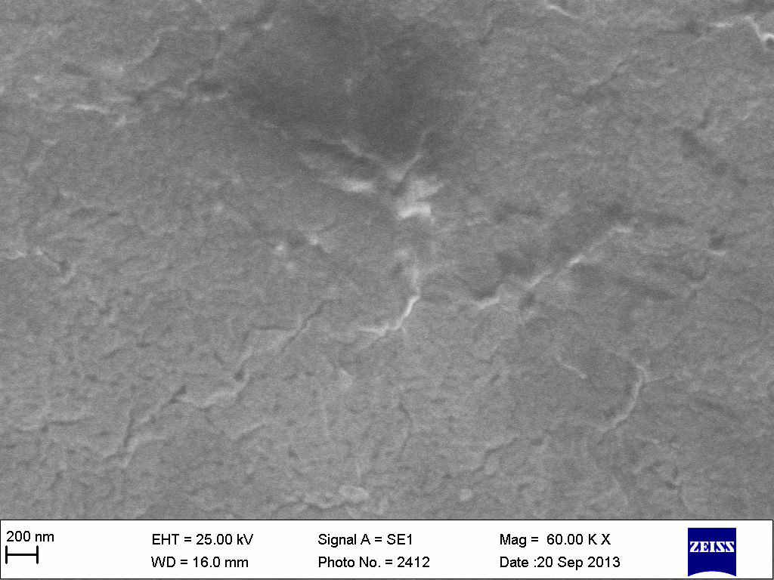a) | 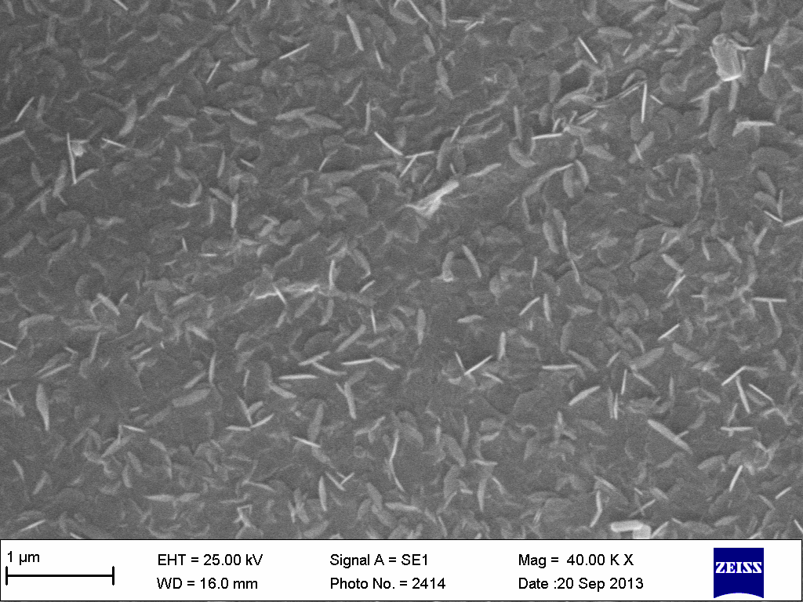b)

Fig. 3: SEM picture of the surface of ZnO: Al layer, produced by PLD method, sample from PET/D2/P2/1 series -a) and PET/D1/P3/1 -b).

Deposited samples were characterized in terms of their optical transmission and electrical resistance. Optical transmission curves of ZnO:Al layers in visible spectrum (Fig. 4) were determined by optoelectronic setup with silicon photodetector and stabilized light source. Obtained optical transmission is sufficiently high, at the average level of 90%.
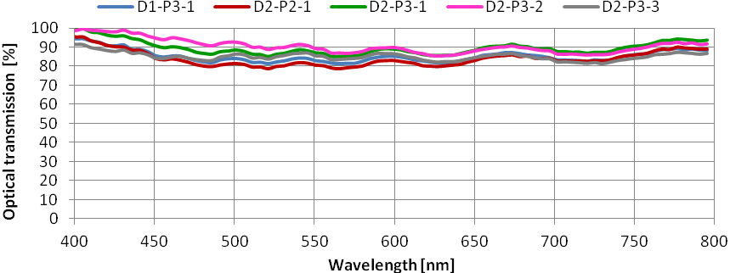
Fig. 4: Optical transmission of ZnO:Al layers deposited on PET foil.
The next step was a verification of electrical and mechanical properties of deposited layers. Resistance per square was measured for each sample before and after a series of dynamic bending cycles, using 4-probe measuring setup, according to A-De Matti method. The procedure of bending was realized using 25 mm diameter cylinder with movement frequency of 3 cycles per second. The results of resistance changes after 200 bening cycles are shown in Table II.

Table II. The resistance per square for ZnO:Al layers before and after series of 200 bending cycles on 25mm diameter cylinder
Sample number | Resistance before bending [Ω/□] | Resistance after bending [Ω/□] | Percentage change [%]
D1-P3-1 | 38 702 | 39 742 | 3
D2-P2-1 | 298 | 399 | 34
D2-P3-1 | 831 | 10 197 | 1 126
D2-P3-2 | 394 | 1 478 | 275
D2-P3-3 | 1 768 | 4 683 | 165

Conclusions and further development
Comparing to previously reported results [9], significant improvement of optical, and electrical parameters, by PLD procedure enhancement was achieved. According to the results (Fig. 4 and Table II), it should be noted that there is an optimal pressure inside the chamber corresponding with an appropriate wavelength of the beam, which influences the highest optical transmission and conductivity. Higher beam wavelenght (D1-P3-1 sample) resulted in higher crystallisation and unacceptable high initial resistnce. The best electro-mechanical properties were observed for layer D2-P2-1 deposited in lower pressure (1.2∙10-3 mbar) than the rest of samples (1.2∙10-2 mbar), which was relatively expected result. Event though, the same sample is characterized by the lowest optical transmission in visible range this, is only few percent difference and as for now it seems to be an acceptable compromise including relatively stable resistance after mechanical treatment.
Nevertheless, it seems that the the problem of efiicient transparent contacts in flexible photovoltaic structures remains not entirely solved by so-far experiments, further improvement of proposed solution is expected to be achieved. The idea is to enchance the effect by fabrication thin ZnO layer before depositing ZnO:Al layer, as it is suggested in literature [11], because pure zinc oxide layer is much better substrate to grow good quality ZnO:Al than amorphous PET foil. This could be achieved in mutli-target PLD setup which allows for in-line dynamic target changing and is a matter of future experiments.
Acknowledgements
The research was conducted within the OPUS project “Transparent emitter electrode for photovoltaic applications, based on carbon nanotubes” supported by the Polish National Science Center.

Author M. Sibiński is a scholarship holder within the project: "Scicentist for łodzkie voivodeship" European Social Found .

References
[1] T. Markvart , L. Castaner , “Solar Cells: Materials, Manufacture and Operation”, Elsevier, Amsterdam, 2006.
[2] M. Pagliaro, R. Ciriminna, G. Palmisano, “Flexible Solar Cells”, Willey-Vch, 2008.
[3] C. Ferekides, D. Marinskiy, V. Viswanathan, B. Tetali, V. Palekis, P.Selvaraj, D. Morel “High efficiency CSS CdTe solar cells”. Thin Solid Films 361-362 (2000) pp. 520-526.
[4] H. Hartmann, R Mach, B. Selle „Wide bandgap II-VI compounds as electronic materials“ Current Topics in Materials Science, Amsterdam 1981 pp. 1-414.
[5] A. Rakhshani:, Electronic and optical properties of fluorine-doped tin oxide films, Journal of Applied Physics Volume: 83 , Issue: 2, 1998, pp 1049 - 1057
[6] K. Goliszewska, E. Kamińska, A. Piotrkowska, J. Rutkowski, E. Kowalczyk, E. Papis, R. Kruszka, T. Piotrkowski, A. Wawro, „Transparent Ohmic contacts to GaSb/In(Al.)GaAsSb photovoltaic cells.” in, EXMATEC 2006, Kadyks, p 133.
[7] M. Sibiński , M. Jakubowska, K. Znajdek, M. Słoma, B. Guzowski: Carbon nanotube transparent conductive layers for solar cells application. Optica Applicata, 2011, vol. XLI, no 2, pp. 375-381
[8] Jae-Hyeong, Jun-Tae Song: Dependence of the electrical and optical properties on the bias voltage for ZnO:Al films deposited by r.f. magnetron sputtering. Thin Solid Films 516 p. 1377-1381, 2008.
[9] A. Apostoluk, Y. Zhu, B. Canut, B. Masenelli, J.-J. Delaunay, K. Znajdek, M. Sibiński, Investigation of luminescent properties of ZnO nanoparticles for their use as a down-shifting layer on solar cells, Phys. Status Solidi C, 1–7 (2013).
[10] L. Dobrzański, A., Drygała.: Laser processing of multicrystalline silicon for texturization of solar cells, Journal of Materials Processing Technology 191 (2007) pp 228–231.
[11] S. Ahn, S., D. Hwang, H. Park, C. Grigoropoulos,: Femtosecond laser drilling of crystalline and multicrystalline silicon for advanced solar cell fabrication, Appl. Phys. A 108, (2012) pp 113–120
[12] R. Pawlak, A. Rosowski, M.Tomczyk, M. Walczak, :Laser microscale technologies: Modeling assisted processes , Proceedings of SPIE - The International Society for Optical Engineering, Volume 8703, 2013, Article number87030N
[13] H. Agura ,A. Suzuki ,T. Matsushita, T. Aoki, M. Masahiro, M. Okuda " Low resistivity transparent conducting Al-doped ZnO films prepared by pulsed laser deposition", Thin Solid Films, 445, p 263, 2003.
[14] M. Sibiński, K. Znajdek, S. Walczak, M. Słoma, M. Górski, A. Cenian, “Comparison of ZnO:Al, ITO and carbon nanotube transparent conductive layers in flexible solar cells applications”, Materials Science and Engineering: B, 177 (2012), pp. 1292-1298.
[15] M. Y. Zhang, G.J. Cheng, “Highly conductive and transparent alumina-doped ZnO films processed by direct pulsed laser recrystallization at room temperature”, Appl. Phys. Lett. 99, (2011), pp. 158-160

